**Web-based Ordering & Ingredient Estimating for Bakery Manufacturer**

Project Management Plan

By

**Miss. Nontra Nonsee 542115026**

**Mr. Parinya Panyanak 542115034**

Department of Software Engineering

College of Arts, Media and Technology

Chiang Mai University

Project Advisor

________________________

**Mr.Phudinan Singkhamfu**

**Document History**

|  |  |  |  |  |  |  |
| --- | --- | --- | --- | --- | --- | --- |
| **Document Name** | **Version** | **Status** | **Date** | **Viewable** | **Reviewer** | **Responsible** |
| **Documents** | | | | | | |
| Web-based Ordering & Ingredient Estimating for Bakery Manufacturer – PMP_V.0.1.docx | V.0.1  - Add Chapter 1  - Fix inappropriate words | Drafted | 18-04-2015 | NN, PP, PS | NN, PP | NN, PP |
| Web-based Ordering & Ingredient Estimating for Bakery Manufacturer – PMP_V.0.3.docx | V.0.3  - Add Chapter 2  - Adjust Deliverables  - Adjust Acronyms & Definitions  - Fix inappropriate words | Drafted | 30-04-2015 | NN, PP, PS | NN, PP | NN, PP |
| Web-based Ordering & Ingredient Estimating for Bakery Manufacturer – PMP_V.0.4.docx | V.0.4  - Add Chapter 3  - Adjust Deliverables  - Adjust Non-Deliverables  - Adjust Acronyms & Definitions  - Fix inappropriate words | Drafted | 01-05-2015 | NN, PP, PS | NN, PP | NN, PP |
| Web-based Ordering & Ingredient Estimating for Bakery Manufacturer – PMP_V.0.6.docx | V.0.6  - Add Chapter 4  - Add Chapter 5  - Adjust Deliverables  - Adjust Chapter 3  - Fix inappropriate words | Drafted | 02-05-2015 | NN, PP, PS | NN, PP | NN, PP |
| Web-based Ordering & Ingredient Estimating for Bakery Manufacturer – PMP_V.0.7.docx | V.0.7  - Add Chapter 6  - Add Chapter 7  - Adjust Quality Factors  - Fix inappropriate words | Drafted | 03-05-2015 | NN, PP, PS | NN, PP | NN, PP |
| Web-based Ordering & Ingredient Estimating for Bakery Manufacturer – PMP_V.0.9.docx | V.0.9  - Add Chapter 8  - Add Chapter 9  - Adjust Configuration Item Table  - Fix inappropriate words | Drafted | 05-05-2015 | NN, PP, PS | NN, PP | NN, PP |
| Web-based Ordering & Ingredient Estimating for Bakery Manufacturer – PMP_V.1.0.docx | V.1.0  - Adjust Chapter 1 - Adjust Quality Factors  - Adjust Project Responsibility  - Adjust Testing  - Adjust Hardware  - Adjust Software  - Adjust Project Schedule  - Adjust Chapter 6  - Fix inappropriate words | Released | 10-05-2015 | NN, PP, PS | NN, PP | NN, PP |

**\*NN = Nontra Nonsee**

**\*PP = Parinya Panyanak**

**\*PS = Phudinan Singkhamfu**

**Table of contents**

**Chapter One | Introduction** 6

1.1 Identification 6

1.2 Scope 6

1.3 Document Overview 6

1.4 Objective 7

1.5 Work Products to be Develop 7

1.5.1 Deliverables and Delivery Instruction 7

1.5.2 Non-Deliverables 13

1.6 Acronyms and Definitions 13

1.6.1 Acronyms 13

1.6.2 Definitions 14

**Chapter Two | Infrastructure** 17

2.1 Software Development Life Cycle 17

2.3 Software Acquisition Plans 18

2.2.1 Design Tools 18

2.2.2 Development Tools 18

2.2.3 Configuration Management Tools 18

2.2.4 Document Tools 18

2.2.5 Operating System 18

2.3 Hardware and Material Resources 19

**Chapter Three | Management Procedures** 20

3.1 Project Team Structure 20

3.2 Project Responsibility 20

3.3 Change Management 20

**Chapter Four | Quality Standard** 21

4.1 ISO29110 for Very Small Entity (VSE) 21

4.1.1 Project Management Process 21

4.1.2 Software Implementation Process 21

**Chapter Five | Quality Planning** 22

5.1 Reviews/Responsibility 22

5.3 Testing 22

**Chapter Six | Schedule and Milestones** 23

6.1 Project Schedule 23

**Chapter Seven | Software Configuration Management** 31

7.1 Software Configuration Management 31

7.2 Filename Format 31

7.3 Project Repository 31

7.4 Software Configuration Item Table 32

**Chapter Eight | Risk Management** 33

8.1 Risk Management Process 33

8.2 Risk Identification and Solutions 34

**Chapter Nine | References** 35

# **Chapter One | Introduction**

Project Name: Web-based Ordering & Ingredient Estimating for Bakery Manufacturer

As a result of a quantity demand, the Phungnoi bakery manufacturer becomes a primary source among wholesalers. Some of the bakery manufacturers have a lot of wholesaler and orders, for example, many branches ordering a fresh bakery products more than ten thousand baths. These leads to the problems that the bakery manufacturer cannot manage the internal information efficiently because of a many factors such as a time, communication, worker, and system. So we have an idea to create a new system that able to manage information efficiently and provide convenient order process on the wholesale side. Then also helps the manufacturer control their ingredient usage in each manufacturing time. This system will make the managing process more reliable and conveniently. The system provides a controlling system function such as an order system, product system, member management system, ingredient management system, ingredient estimation, and report system.

## 1.1 Identification

This a document is the software project management plan, which described the process of the Web-based Ordering & Ingredient Estimating for Bakery Manufacturer. This a document included planning, scheduling, activities, evaluating overall of the project and the risk that may possible for managing the software process activities.

## 1.2 Scope

The Web-based Ordering & Ingredient Estimating for Bakery Manufacturer is a management system that helps the admin can manage manufacture’s information efficiency. Then the system helps the wholesaler to manage their order easier, and the worker also can apply ingredient usage’s information with a traditional workflows. The project focuses on implementation of the general order system and supports the process of the manufacturer system. The objective of this project is to develop management system that apply to the Phungnoi bakery manufacturer for controlling information’s correction and ingredient usage standards. An another objective is to develop a system that support conveniently ordering for the Phungnoi bakery’s wholesalers.

## 1.3 Document Overview

The purpose of the Web-based Ordering & Ingredient Estimating for Bakery Manufacturer development plan is to guide the developer while develop the system. This project has developed in the process of making the project and all documents according to the software quality assurance. In this project will use the ISO29110 standard that suit with very small entity.

## 1.4 Objective

Firstly, the implement a software management system which would be include many management features, such as member management, product management, order management, ingredient estimation, report system, etc.

Second objective is to develop web-based online ordering for the wholesalers. This objective is to provide order management system and other services support wholesale side.

Third objective is to develop ingredient estimating function for control budget and standard of the bakery manufacturer.

Where the last objective is to study the iterative development process and adapt the software engineering methodologies and knowledge that we have learned from the previous courses for the senior project.

## 1.5 Work Products to be Develop

### 1.5.1 Deliverables and Delivery Instruction

|  |  |  |  |  |
| --- | --- | --- | --- | --- |
| **No.** | **Deliverable** | **Media** | **No. of Copies** | **Date** |
| 1 | The Project Proposal | Document | 3 | 16 June 2015 |
| 2 | The Progress Report I   * Project Plan V.1.0 * Web-based Ordering & Ingredient Estimating for Bakery Manufacturer Web Application V.1.0   **Progress I**: Web-based Ordering & Ingredient Estimating for Bakery Manufacturer web application provides member management system and product management system functions  Features   * Login to web application * Logout from web application * Add members information;   - username  - password  - first name  - last name  - phone number  - address  - profile picture  - role name   * View members information;   - member ID  - username  - first name  - last name  - phone number  - address  - profile picture  - role name  - last sign in date  - create date   * Edit members information;   - username  - password  - first name  - last name  - phone number  - address  - profile picture  - role name   * Remove existing members * Search member information;   - member ID  - username  - first name  - last name  - phone number  - address  - role name  - last sign in date   * Add bakery product information;   - product name  - price  - category  - product picture  - information   * Edit existing bakery product information;   - product name  - price  - category  - product picture  - information   * View existing bakery product information;   - product ID  - product name  - price  - category  - product picture  - information   * Remove existing bakery product * Search bakery product information;   - product ID  - product name  - price  - category  Documentation   * Software Requirement Specification Document V.1.0 * Software Design Document V.1.0 * Software Test Plan Document V.1.0 * Software Test Record V.1.0 * Traceability Record V.1.0 * Project Status Report V.1.0 * Executive Summary V.1.0 | Document  Software  Document  Document  Document  Document  Document  Document  Document | 3  1  3  3  3  3  3  3  3 | 17 March 2015  17 March 2015  17 March 2015 |
| 3 | The Progress Report II   * Project Management Plan V.2.0 * Web-based Ordering & Ingredient Estimating for Bakery Manufacturer Web Application V.2.0   **Progress II**: Web-based Ordering & Ingredient Estimating for Bakery Manufacturer web application provides order management system and ingredient management system functions  Features   * Order bakery product to product cart * Edit current order’s information on time * Cancel current order’s information on time * Select repeat previous order’s information * Save unfinished product cart and return to continue later * View all bakery product list in each order * View total price and discount of each order * Send finished product cart to the ordering process * Display order notification * View current order list;   - member ID  - first name  - last name  - order ID  - delivery date  - total price  - order status   * View current order information;   - member ID  - first name  - last name  - order ID  - order date  - delivery date  - product ID  - product name  - product quantity  - total price  - discount  - order status   * Calculate total number of bakery product in daily order * Search ordered history;   - member ID  - first name  - last name  - order ID  - delivery date   * View ordered history list;   - member ID  - first name  - last name  - order ID  - delivery date  - total price  - order status   * View ordered history information   - member ID  - username  - first name  - last name  - order ID  - order date  - delivery date  - product ID  - product name  - product quantity  - total price  - discount  - order status   * Mark progressive of order status while the order in the preparation stage * View progress order status while the order in the preparation stage * Comment the suggestion message to the feedback page * Add ingredient information;   - ingredient name  - ingredient picture  - category   * View ingredient information;   - ingredient ID  - ingredient name  - ingredient picture  - category   * Edit ingredient information;   - ingredient name  - ingredient picture  - category   * Remove existing ingredient * Search ingredient information;   - ingredient ID  - ingredient name  - category  Documentation   * Software Requirement Specification Document V.2.0 * Software Design Document V.2.0 * Software Test Plan Document V.2.0 * Software Test Record V.2.0 * Traceability Record V.2.0 * Project Status Report V.2.0 * Executive Summary V.2.0 | Document  Software  Document  Document  Document  Document  Document  Document  Document | 3  1  3  3  3  3  3  3  3 | 30 April 2015  30 April 2015  30 April 2015 |
| 4 | The Final Progress Report   * Project Management Plan V.3.0 * Web-based Ordering & Ingredient Estimating for Bakery Manufacturer Web Application V.3.0   **Final Progress**: Web-based Ordering & Ingredient Estimating for Bakery Manufacturer web application provides ingredient estimation system and report system functions  Features   * Add menu recipe information;   - product name  - ingredient name  - ingredient quantity  - units   * View menu recipe list   - recipe ID  - product name   * View menu recipe information;   - recipe ID  - product ID  - product name  - product picture  - information  - category  - ingredient ID  - ingredient name  - ingredient quantity  - units   * Edit menu recipe information;   - product name  - ingredient name  - ingredient quantity  - units   * Remove existing menu recipe * Search menu recipe information;   - recipe ID  - product ID  - product name  - ingredient ID  - ingredient name   * Calculate current ingredient usage * Choose a period to estimating ingredient usage from the past * View ingredient usage list;   - product ID  - product name   * View ingredient usage information;   - product ID  - product name  - ingredient ID  - ingredient name  - ingredient quantity  - units   * Make a document report * View content in text report * Save and print text report as a PDF file format * Make a graph from ordered data by day, month and year * View statistical graph data;   - graph image  - statistical portion   * Save and print graph statistical as a PDF file format   Documentation   * Software Requirement Specification Document V.3.0 * Software Design Document V.3.0 * Software Test Plan Document V.3.0 * Software Test Record V.3.0 * Traceability Record V.3.0 * Project Status Report V.3.0 * Executive Summary V.3.0 | Document  Software  Document  Document  Document  Document  Document  Document  Document | 3  1  3  3  3  3  3  3  3 | 02 July 2015  02 July 2015  02 July 2015 |

### 1.5.2 Non-Deliverables

|  |  |  |  |  |
| --- | --- | --- | --- | --- |
| **No.** | **Non-Deliverable** | **Media** | **No. of Copies** | **Date** |
| 1 | 30 Seconds Video Presentation | File | 1 | 17 September 2014 |
| 2 | Abstract 150 words | File | 1 | 17 September 2014 |
| 3 | Poster Presentation | Poster | 1 | 18 September 2014 |

## 1.6 Acronyms and Definitions

### 1.6.1 Acronyms

SRS Software Requirement Specification

URS User Requirement Specification

SDD Software Design Document

OS Operation System

VSE Very Small Entity

PMP Project Management Plan

SI Software Implementation

IDP Iterative Development Process

SCI Software Configuration Item

SCM Software Configuration Management

SQA Software Quality Assurance

AD Activity Diagram

UC Use Case

IEEE Institute of Electrical and Electronics Engineers

RTM Requirement Traceability Matrix

UI User Interface

UTR Unit Testing Record

STR System Testing Record

### 1.6.2 Definitions

Feature Transformation of input parameters to output parameters based on a specified algorithm. It describes the functionality of the product in the language of the product. Used for requirements analysis, design, coding, testing or maintenance. [8] [IEEE90]

IEEE Institute of Electrical and Electronics Engineers. Biggest global interest group for engineers of different branches and computer scientists. [8] [IEEE90]

Plan A documented series of tasks requires meeting and objective, typically including the associated schedule, budget, resources, organizational description and work breakdown structure. [IEEE90]

Project Management The application of knowledge, skills, tools, and techniques to project activities in order to meet or exceed stakeholder needs and expectations from a project. [8]  [IEEE90]

Project Plan A formal, approved document used to guide both project execution and project control. The primary uses of the project plan are to document planning assumptions and the decision, to facilitate communication among stakeholders, and to document approved scope, cost, and schedule baseline. [8] [IEEE90]

Risk Management The systematic application of management policies, procedures and practices to the tasks of identifying, analyzing, evaluating treating and monitoring risk. [8] [IEEE90]

Validation Confirmation by examination and provision of objective evidence that the particular requirements for a specified intended use fulfilled. Part of quality control. [9] [IEEE90]

Verification Confirmation at the end of the process by examination and provision of objective evidence that specified requirements to the process has fulfilled. Part of quality control. [8] [IEEE90]

Traceability The ability to trace the history, application or location of an item or activity, or work products or activities, by means of recorded identification. The establishment and maintenance of relationships between such items. Horizontal traceability describes the relationship between work products of the same type (e.g., customer requirements). Vertical traceability describes the relationship between work products which build upon each other or are derived from each other (e.g., from customer requirements to qualification test cases). Bidirectional reliability allows to directly following relationship in both directions. [8] [IEEE90]

Configuration Management A was discipline applying technical and administrative direction and surveillance to: identify and document the functional and physical characteristics of a configuration item, control change processing implementation status, and verify compliance with specified requirements. [10] [IEEE90]

Design The period the software life cycle during which the design for architecture, software components, interfaces, and design are created, documented, and verified to satisfy the requirement. [IEEE90]

Implementation The period the software life cycle during which a software product is create a documentation and debugged. [IEEE90]

Work Product Any tangible item that results from a project function, activity, or task. Examples of work products include customer requirement, project plan, design documents, source, and object code, user’s manuals.

Software Computer programs, procedures, and associated documentation and data pertaining to the operation of a computer system. [11] [IEEE90]

Software Engineering The application of a systematic, disciplined, quantifiable approach to the development, operation, and maintenance of software; that is, the application of engineering to software. [8] [IEEE90]

Quality Assurance (1) A planned and systematic pattern of all actions necessary to provide adequate confidence that an item or product conforms to established technical requirement. [12] [IEEE90]

(2) A set of activities designed to evaluate the process by which producers developed or manufactured. [12] [IEEE90]

# **Chapter Two | Infrastructure**

## Software Development Life Cycle

The Iterative process model is iterating on steps as the project development with requirements. Iterative model iterates Requirement, Design, Development (Implement), Test phases, and Deployment (Evaluate, Feedback) for each requirement and builds up quality until complete. The advantage of iterative model is building and improving the product step by step. Thus, developer can track the defects at early stages and avoid flow of defects.

Web-based Ordering & Ingredient Estimating for Bakery Manufacturer project using iterative development process, because it does not attempt to start with a full specification of requirements. We needed to develop the iterative way to review and improve the software and its documents for each development progress until it has finished. [7]

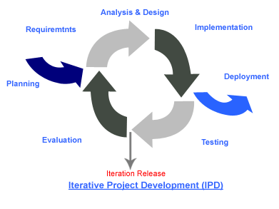

**Figure 1: Iterative Development Model [1]**

## Software Acquisition Plans

### 2.2.1 Design Tools

* Smart Draw 2013
* Visual Paradigm for UML 12.1
* Paint

### 2.2.2 Development Tools

* Microsoft SQL Server Management Studio
* Microsoft Visual Studio Ultimate
* Tortoise SVN
* Internet Information Service

### 2.2.3 Configuration Management Tools

* Github
* Google Chrome
* Firefox

### 2.2.4 Document Tools

* Microsoft Office Word
* Microsoft Office PowerPoint
* Microsoft Office Excel
* Notepad ++
* Adobe Reader 9

### 2.2.5 Operating System

* Windows 7, Window 8

## 2.3 Hardware and Material Resources

* Computers
* **Name:** Sony VAIO-VAIO

**Processor:** Intel® Pentium® Processor T4300 (2.10 GHz)

**Memory:** 2.00 GB

**Graphics:** Intel® Graphics Media Accelerator HD

**Operating System:** Window® 7 Home Basic (64-bit)

* **Name:** Sony VAIO

**Processor:** Intel® Core (TM) I3-3120M (2.5 GHz)

**Memory:** 4.00 GB

**Graphics:** Radeon Graphics System

**Operating System:** Window® 8 Based Processor (64-bit)

# **Chapter Three | Management Procedures**

## 3.1 Project Team Structure

|  |  |  |
| --- | --- | --- |
| **No.** | **Participants** | **Roles** |
| 1 | Miss. Nontra Nonsee | Development Team Member |
| 2 | Mr. Parinya Panyanak | Development Team Member |
| 3 | Aj. Phudinan Singkhamfu | Project Advisor |

## 3.2 Project Responsibility

|  |  |  |
| --- | --- | --- |
| **No.** | **Participants** | **Responsibility** |
| 1 | Miss. Nontra Nonsee | Feasibility Study |
| All members | Project Proposal |
| Miss. Nontra Nonsee | Project Requirements Specification |
| Miss. Nontra Nonsee | Project Management Plan |
| Mr. Parinya Panyanak | Project Software Design Document |
| Mr. Parinya Panyanak | Implementation |
| Mr. Parinya Panyanak | Software Test Report Document |
| 2 | Aj. Phudinan Singkhamfu | Review Document |
| Approve The Document |
| Approve Change Document |

## 3.3 Change Management

Change Management manages all of the changes in the project during the development process. All of the change requests will be recording into the change management document.

We have a strategy for managing the changes by following these rules:

* Create requirement traceability to trace change document.
* Specify version of each document.
* Determine baseline document version.
* Approving the change request by project advisor.

# **Chapter Four | Quality Standard**

## 4.1 ISO29110 for Very Small Entity (VSE)

ISO29110 is a guide applies to a Very Small Entity (VSE), enterprise, organisation, department or project up to 25 people, dedicated to software development. The Guide provides Project Management and Software Implementation processes. It integrate practices based on the selection of ISO/IEC 12207- *Systems and Software Engineering —Software Life Cycle Processes* and ISO/IEC 15289 - *Software Engineering – Software Life Cycle Process – guidelines for the content of software life cycle process information products (documentation)* standards elements. [4]

### 4.1.1 Project Management Process

The purpose of the Project Management Process is to improve the success rate of projects in all areas of knowledge, which allows complying with the project’s objectives in the expected quality, time and cost. [3]

**Activities**

* Project Planning Process
* Project Plan Execution Process
* Project Assessment and Control Process
* Project Closer Process

### 4.1.2 Software Implementation Process

The purpose of the Software Implementation process is the systematic performance of the analysis, design, construction, integration and tests activities for new or modified software products according to the specified requirements. [4]

**Activities**

* Software Implementation Initiation Process
* Software Requirements Analysis Process
* Software Architectural Design Process
* Software Construction Process
* Software Integration and Test Process
* Software Delivery Process

# **Chapter Five | Quality Planning**

## 5.1 Reviews/Responsibility

|  |  |  |  |  |
| --- | --- | --- | --- | --- |
| **Stage Exit Review** | | | | |
| **No.** | **Stage** | **Review Item** | **Responsibility** | **Reviewer** |
| 1 | Project Planning | Project Management Plan | NN | All members  Advisor |
| 2 | Requirements Specification | Project Proposal | All members | All members  Advisor |
| Software Requirement Specification | NN | All members  Advisor |
| 3 | Architecture and Detailed Design | Software Design Document | PP | All members  Advisor |
| 4 | Development | Implementation | PP | All members  Advisor |
| Unit Test Report | PP | All members  Advisor |
| 5 | Software Testing | System Test Report | PP | All members  Advisor |
| 6 | Project Monitoring and Control | Traceability Record | NN | All members  Advisor |
| Project Status Report | NN | All members  Advisor |
| Change Request | NN | All members  Advisor |

## 5.3 Testing

|  |  |  |  |
| --- | --- | --- | --- |
| **Test Process** | | | |
| **No.** | **Test** | **Verification** | **Responsibility** |
| 1 | Unit Testing | All members  Advisor | Parinya Panyanak |
| 2 | System Testing | All members  Advisor | Parinya Panyanak |

# **Chapter Six | Schedule and Milestones**

## 6.1 Project Schedule

According from Figure 2 to Figure 6 was show the schedule and milestones of Web-based Ordering & Ingredient Estimating for Bakery Manufacturer. During period of time, there are work terminologies. And the description is shown below that:

* **Feature#1:** Member Management System

**-** The admin can activate member.

**-** The admin can manage member information by provides the username, password, first name, last name, phone number, address, and role name.

**-** The admin can specify member’s role in the system.

**-** The admin can display a member list.

**-** The admin can view a member information consist of the member ID, username, first name, last name, phone number, address, role name, create date, and last sign in date.

- The member can sign in to the system.

**-** The admin can search a member information by the member ID, username, first name, last name, phone number, address, role name, and last sign in date.

- The member can view a verification notification.

- The member can logout from the system.

- The member can update personal profile.

- The member can display own personal information consist of the member ID, username, first name, last name, phone number, address, role name, create date, and last sign in date.

- The member can view personal information consist of the member ID, username, first name, last name, phone number, address, role name, create date, and last sign in date.

- An application provides a member management system.

* An application provides a validation message when the error occurrs.

- An application provides a member information consist of the member ID, username, first name, last name, phone number, address, role ID, role name, create date, and last sign in date.

* **Feature#2:** Product System

- The admin can manage a product information by provides the product name, product picture, category, and price.

- The admin can display a bakery product list such as the product ID, product name, and price.

- The admin can display a bakery product information consist of the product ID, product name, category, and price.

- The member can search a bakery product information by the product ID, product name, category, and price.

- The member can view a bakery product list such as the product ID, product name, and price.

- The member can view a bakery product information consist of the product ID, product name, category, and price.

- An application provides a product management system.

* An application provides a validation message when the error occurrs.

- An application provides a product information consist of the product ID, product name, product picture, price, and category.

* **Feature#3:** Order System

- The wholesaler can order a bakery product and manage them on the time constraint.

- The wholesaler can save unfinished product cart while they already input a bakery product quantity but not complete yet. Then the wholesaler can return to continue their order later.

- The wholesaler can make an order by repeat ordered history information.

- The wholesaler can view a bakery product list at the summary order.

- The wholesaler can view the total price and discount from orders.

- The wholesaler can send a finished product cart to the system.

* The worker can view current an order information consist of the member ID, first name, last name, order ID, product ID, product name, product quantity, total price, discount, and order status.
* An application provides the total orders in daily.
* The worker can know the total orders in daily.

- The worker can mark a progressive of order status while the order in each stage.

- The wholesaler can view own order status on the stage.

- An application provides an order management system.

* An application provides a validation message when the error occurrs.

- An application provides an order information consist of the order ID, order date, delivery date, product ID, product name, product quantity, total price, discount, category, and order status.

* The wholesaler can search the own ordered history by the filter keywords of the received date, delivery date, product name, and order status.
* The wholesaler can view the own order history such as the order ID, total price, order status, and delivery date.
* The wholesaler can view the own order history information consist of the order ID, product ID, product name, product quantity, delivery date, total price, discount, and order status.
* The worker can search all order history by the filter keywords of the username, first name, received date, and delivery date.
* The worker can view all order history such as the member ID, first name, last name, order ID, total price, order status, and delivery date.
* The worker can view all order history information consist of the order ID, member ID, first name, last name, product ID, product name, product quantity, delivery date, total price, discount, and order status.
* **Feature#4:** Ingredient Management System
* The admin can manage ingredient information by provides the ingredient name, category, and ingredient picture.
* The admin can search ingredient information by the filter keywords of the ingredient name, and category.
* The admin can view ingredient information consist of the ingredient ID, ingredient name, category, and ingredient picture.
* An application provides an ingredient management system.
* An application provides a validation message when the error occurrs.
* An application provides an ingredient information consist of the ingredient ID, ingredient name, category, and ingredient picture.
* **Feature#5:** Ingredient Estimation
* The admin can manage a menu recipe information by provides the product name, ingredient name, ingredient quantity, and units.
* The admin can search menu recipe information by the filter keywords of the product name, and ingredient name.
* The admin can view all menu recipe list.
* The admin can view a menu recipe information consist of the product ID, product name, product picture, ingredient name, and ingredient quantity.
* An application provides a validation message when the error occurrs.
* An application provides a menu recipe information consist of the product ID, product name, ingredient name, ingredient quantity, and product picture.
* An application provides an ingredient estimation function.
* The worker can view current ingredient estimation result consist of the product ID, product name, ingredient name, ingredient quantity, and units.
* The worker can choose a period at a start to end for processing ingredient estimation result.
* The worker can view the ingredient usage results consist of the product ID, product name, ingredient name, and ingredient quantity
* **Feature#6:** Report System
* The wholesaler and worker can create a report according their permission.
* The wholesaler and worker can view the report contents.
* The wholesaler and worker can save and print a report as a PDF file format.
* An application provides a report system.
* The wholesaler and worker can create a chart by choosing the filter keywords of the day, month, and year.
* The wholesaler and worker can view a chart data consist of the chart image and statistical data.
* An application provides convert function from the existing statistical data to be a chart.

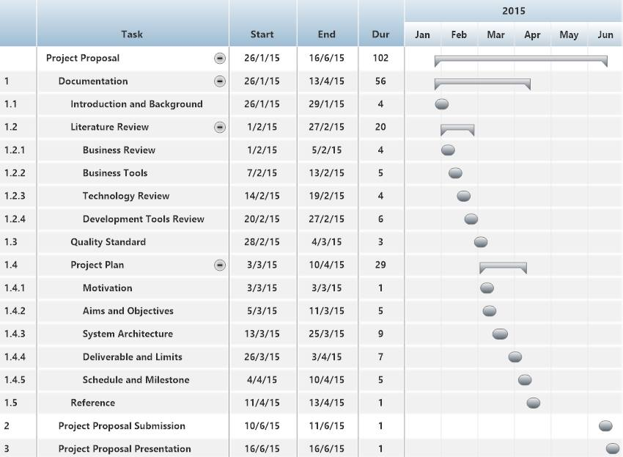

**Figure 2: Proposal Milestone**

As shown in figure 2, There are the details of each task that our have done with the documentation which represent by form of start date, end date, and duration.

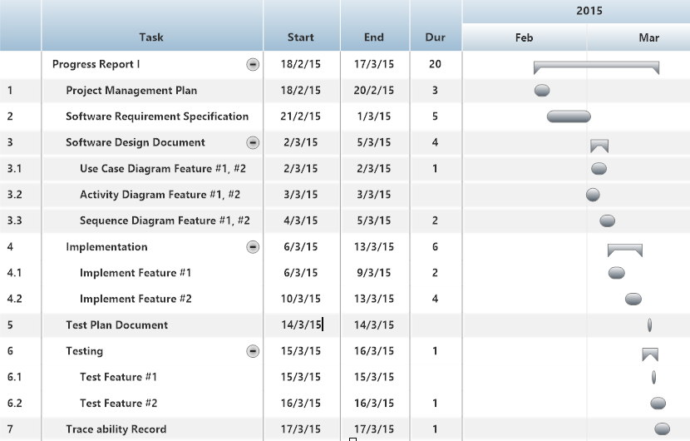

**Figure 16: Progress Report I Milestone**

As shown in figure 16, We will start develop the feature#1 and #2. We will also begin to do the development plan, quality plan, software requirement specification, software design, test plan, test record, and traceability record. It is representing the form of a start date, end date, and duration.

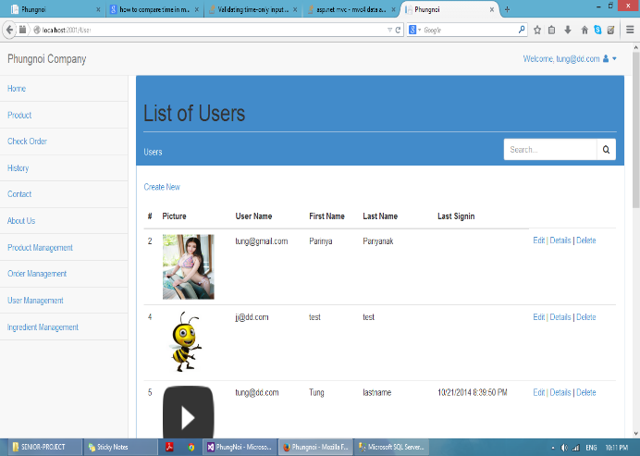 **Figure 17: Member Management System Example**

As shown in figure 17, it is an example of member list page in a first feature is a member management system.

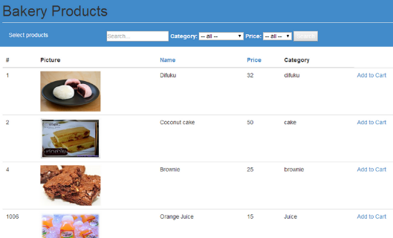 **Figure 18: Product System Example**

As shown in figure 18, it is an example of a bakery product page in a second feature is a product system.

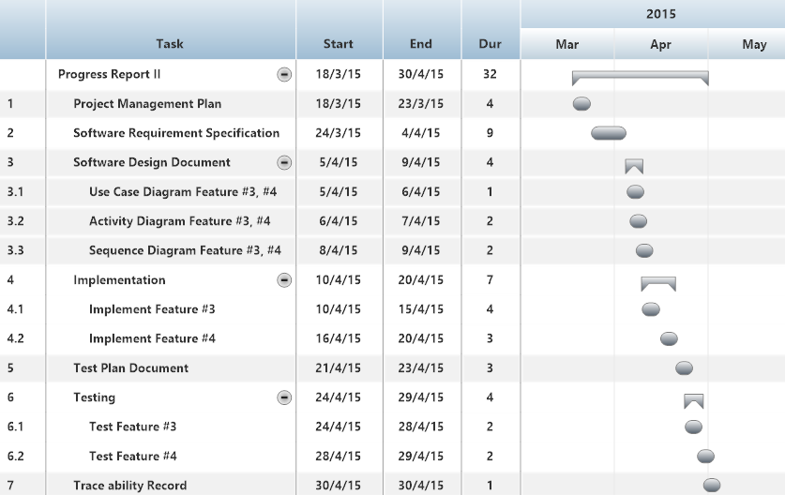

**Figure 19: Progress Report II Milestone**

As shown in figure 19, We will start develop the feature#3 and #4. We will also begin to do the development plan, quality plan, software requirement specification, software design, test plan, test record, and traceability record. It is representing the form of a start date, end date, and duration.

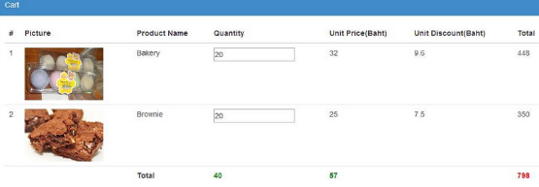  **Figure 20: Order System Example**

As shown in figure 20, it is an example of product cart page in a third feature is an order system.

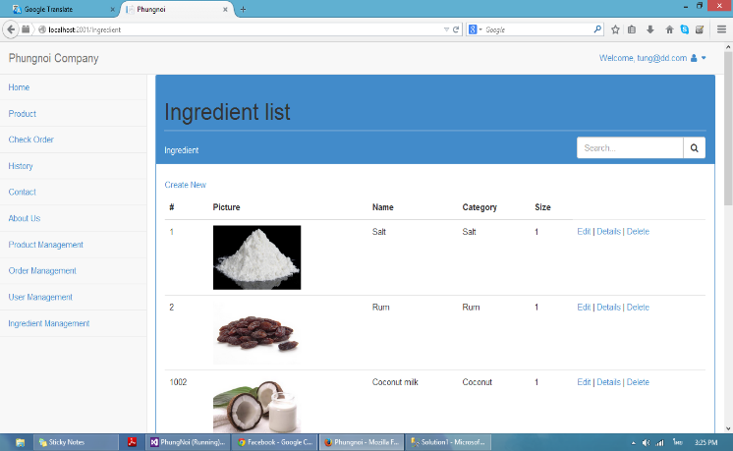

**Figure 21: Ingredient Management System Example**

As shown in figure 21, it is an example of an ingredient list page in a fourth feature is an ingredient management system.

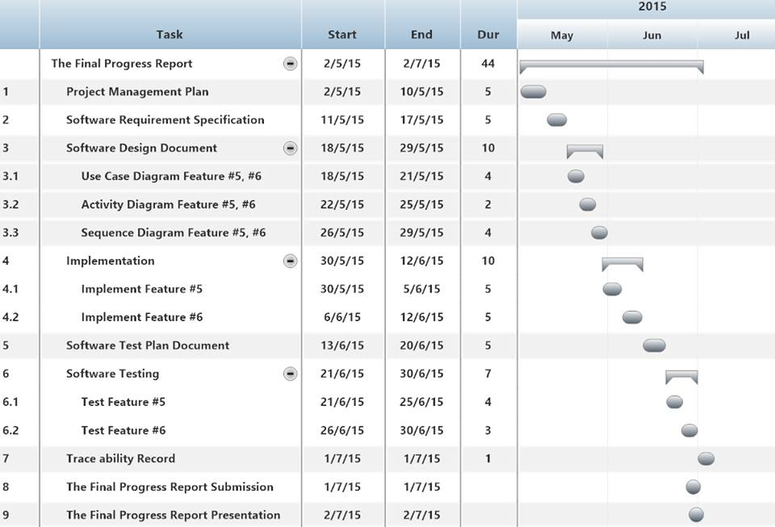

**Figure 22: Final Progress Report Milestone**

As shown in figure 22, We will start develop the feature#5 and #6. We will also begin to do the development plan, quality plan, software requirement specification, software design, test plan, test record, and traceability record. It is representing by form of a start date, end date, and duration.

**Figure 23: Ingredient Estimation Example** 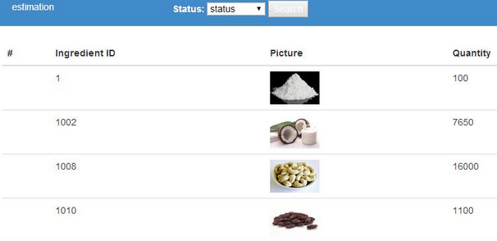

As shown in figure 23, it is an example of an ingredient estimation page in a fifth feature is an ingredient estimation system.

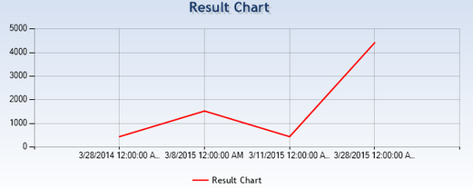 **Figure 24: Report System Example**

As shown in figure 24, it is an example of a chart page in a sixth feature is a report system.

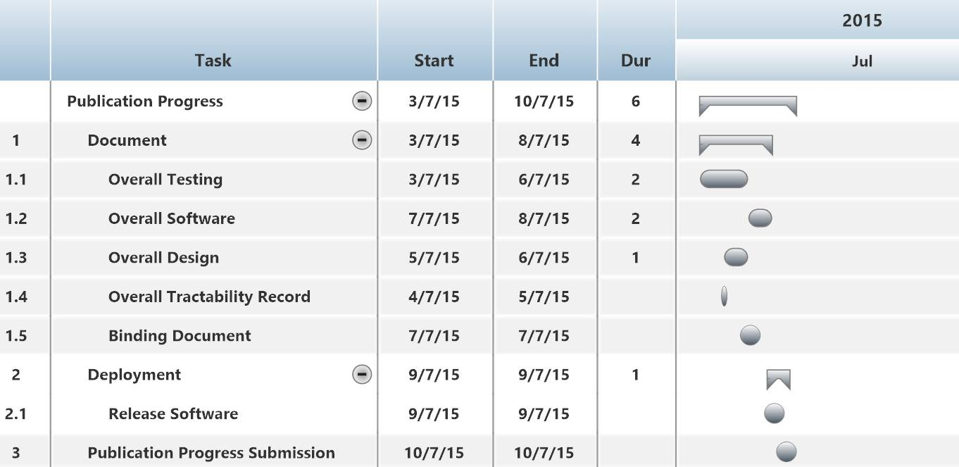

**Figure 25: Publication Milestone**

As shown in figure 25, We will start to update the development and deployment that represent the form of a start date, end date, and duration.

# **Chapter Seven | Software Configuration Management**

## 7.1 Software Configuration Management

Software Configuration Management is a set of activities designed to control change by identifying the work products that are likely to change, establishing relationships among them, defining mechanisms for managing different versions of these work products, controlling the changes imposed, adding, and reporting on the changes made. In other words, SCM is a methodology to control and manage software development project. [6]

## 7.2 Filename Format

For the filename format that we using for all project document is: [Project name]-[Document name]_[Version].file type

## 7.3 Project Repository

D:\Senior Project

|  |  |  |  |  |  |  |
| --- | --- | --- | --- | --- | --- | --- |
| **No.** | **Item name** | **File name** | **File Type** | **Owner (Role)** | **Repository (Path)** | **Baseline Version** |
| 1 | Project Proposal | Web-based Ordering & Ingredient Estimating for Bakery Manufacturer – Project Proposal_V.1.4 | .docx | PP, NM | D:\Senior Project\Project Proposal\Docx\Project Proposal | 1.4 |
| 2 | Project Management Plan | Web-based Ordering & Ingredient Estimating for Bakery Manufacturer – PMP_V.3.0 | .docx | PP, NM | D:\Senior Project\Project Final\Docx\PMP | 3.0 |
| 3 | Software Requirement Specification | Web-based Ordering & Ingredient Estimating for Bakery Manufacturer – SRS_V.3.0 | .docx | PP, NM | D:\Senior Project\Project Final\Docx\SRS | 3.0 |
| 4 | Software Design Document | Web-based Ordering & Ingredient Estimating for Bakery Manufacturer – SDD_V.3.0 | .docx | PP, NM | D:\Senior Project\Project Final\Docx\SDD | 3.0 |
| 5 | Software Test Plan Document | Web-based Ordering & Ingredient Estimating for Bakery Manufacturer – Test Plan_V.3.0 | .docx | PP, NM | D:\Senior Project\Project Final\Docx\Test Plan | 3.0 |
| 6 | Software Test Record | Web-based Ordering & Ingredient Estimating for Bakery Manufacturer – Test Record_V.3.0 | .docx | PP, NM | D:\Senior Project\Project Final\Docx\Test Record | 3.0 |
| 7 | Traceability Record | Web-based Ordering & Ingredient Estimating for Bakery Manufacturer – TR_V.3.0 | .docx | PP, NM | D:\Senior Project\Project Final\Docx\TR | 3.0 |
| 8 | 30 Seconds Video Presentation | Web-based Ordering & Ingredient Estimating for Bakery Manufacturer – VDO_V.1.0 | .mp4 | PP, NM | D:\Senior Project\Show Pro\VDO | 1.0 |
| 9 | Poster Size A1 | Web-based Ordering & Ingredient Estimating for Bakery Manufacturer – Poster_V.1.0 | .png | PP, NM | D:\Senior Project\Show Pro\Poster | 1.0 |
| 10 | Software Product | Web-based Ordering & Ingredient Estimating for Bakery Manufacturer – Software_V.3.0 | .zip | PP, NM | D:\Senior Project\Project Final\Product | 3.0 |

## 7.4 Software Configuration Item Table

# **Chapter Eight | Risk Management**

Risk management is concerned with identifying risks and drawing up plans to minimize their effect on the project. [5]

A risk is probability that some adverse circumstance will occur. [13]

- Project risks affect schedule or resources.

- Product risks affect the quality or performance of the software being developed.

- Business risks affect the project team during developing or procuring the software.

Identified risks at the start of the project and the start of the development phase. All identified risks are documented and assessed in the Risk Management Process by the Project Development Team. In the Risk Management Process defines the possible risks, solution of them, and who is responsible for. [14]

## 8.1 Risk Management Process

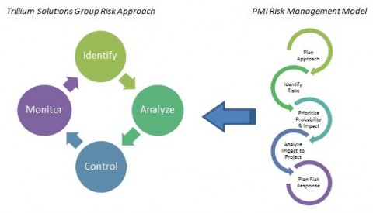

**Figure 3: Risk Management Process Model [2]**

1. Risk identify: identify the project, product, and business risks.

2. Risk analyze: Assess the likelihood and consequences of the risks.

3. Risk controlling: Draw up plans to avoid or minimize the effects of the risks.

4. Risk monitoring: Monitor the risks throughout the project.

## 8.2 Risk Identification and Solutions

|  |  |  |  |
| --- | --- | --- | --- |
| **No.** | **Risk Statement** | **Risk Solution** | **Priority** |
| 1 | The requirements might be change. | * Meeting and discuss the impact of the changed requirements with the team member and project advisor. * Design system which changed requirements and related with the other requirements. * Use software configuration management and follow change management step. | High |
| 2 | During the implementing, the internet maybe out of order or slow. | * Change the working place. | Medium |
| 3 | The deliverables maybe delay. | * Try to study more hard than previous work. * Ask a professional to make faster understand. * Try to follow the schedule and milestone. | High |
| 4 | Team member maybe get engaged and can’t develop the project. | * Assign work to left team member who doesn’t get involved. | Low |
| 5 | Budget of developing may not enough. | * Ask for more budgets from project advisor. | Low |
| 6 | Work products are not submitted on time. | * Establish the project plan. * Develop project follow the project plan. | High |
| 7 | Work products are not traceable. | * Create the traceability record. | Medium |
| 8 | Team member lack skill and knowledge. | * Team member is tutoring implementation. * Ask for assistance and support from textbooks, websites, experienced developer, and advisor. | High |
| 9 | Ambiguous responsibility. | * Always discuss the work together. | Medium |
| 10 | Team member misunderstand system work. | * The member’s review system before development phase and use diagram to explain system working. | High |
| 11 | Human resource not enough. | * Planning schedule and hard working. | Medium |
| 12 | Unfamiliar with testing process. | * Studying test technique during the test design. | Medium |
| 13 | The computer crash. | * Always save all file in Github repository. | Medium |
| 14 | Bad communication between team members | * Try to understand each other and exchange more information together. | Medium |

# **Chapter Nine | References**

[1] “Iterative Development Model” [Image]. (2008). Retrieved 17 April 2014, from <http://www.testingexcellence.com/iterative-model/>

[2] “Risk Management Model” [Image]. (2012). Retrieved 6 May 2014, from <http://trilliumsg.com/insights/2012/06>

[3]  Wikipedia “Project Management Process” [Online]. (2009). Retrieved 17 March 2014, from <http://en.wikipedia.org/wiki/Project_Management_Professional>

[4]  “Software Implementation Process” [Online]. (n.d.). Retrieved 17 March 2014, [http://profs.etsmtl.ca/claporte/English/VSE/Deploy-Pack/Entry%20Profile-DP](http://profs.etsmtl.ca/claporte/English/VSE/Deploy-Pack/Entry%20Profile-DP-Software)

[5] “Project Management” [Online]. (n.d.). Retrieved 30 September 2014,

<http://www.cs.umd.edu/~atif/Teaching/Spring2010/Slides/12.pdf>

[6] “How You Can Benefit from Software Configuration Management” [Online]. (2002). Retrieved 30 September 2014, <http://www.informit.com/articles/article.aspx?p=26858>

[7] “Software Development Life Cycle” [Online]. (2011). Retrieved 30 September 2014,

<http://technicaltutorial.blogspot.com/2011/07/software-development-life-cycle.html>

[8] “Software Measurement” [Online]. (n.d.). Retrieved 30 September 2014, <http://metrics.cs.uni-magdeburg.de/glossary.html>

[9] “Validation Overview” [Online]. (2005). Retrieved 30 September 2014, <http://cstl.nist.gov/strbase/validation/ValidationOverview.pdf>

[10] “Controlled Document and Record Management Procedure” [Online]. (2007). Retrieved 30 September 2014, <http://www.complianceonline.com/images/supportpages/doxpub/Sample_Document_Control_SOP.pdf>

[11] “Definition of Terms” [Online]. (2009). Retrieved 30 September 2014, <http://www.fnal.gov/directorate/AC/ac/ac_2009/20090317/Definition%20of%20QA-CA%20Terms%20Rev2%2017Mar09.pdf>

[12] “Software Quality Assurance” [Online]. (2008). Retrieved 30 September 2014, <http://sqa.fyicenter.com/FAQ/Testing-Techniques/Software_Quality_Assurance.html>

[13] “Software Project Management” [Online]. (2013). Retrieved 30 September 2014, <http://pratikshya.com.np/article/software-project-management/>

[14] “The project manager should be risk taker or risk averse?” [Online]. (2013). Retrieved 30 September 2014, <https://www.linkedin.com/groups/project-manager-should-be-risk-37888.S.242259552?flag>